MURRAY GIRLS’ HIGH SCHOOL, WUSI - TAITA

Kenya Certificate of Secondary Education MGHS MOCK SERIES 1
511/3 MUSIC FORM 1V PAPER 3
MARCH 2025 - 2½ hours
Name…………………………………………………………… index no ………………..
Candidate’s Signature………………………………………… Date…………………….
Instructions to candidates
- Write your name and index number in the spaces provided.
- Sign and write the date of the examination in the spaces provided above.
- Answer all the questions in this paper.
- In question 4 choose any two of the questions numbered (a), (b), (c) and (d).
- All answers must be written in the spaces provided.
- This paper consists of 14 printed pages.
- Candidates should check the question paper to ensure that all the pages are printed as indicated and that no questions are missing.
- Candidates should answer the questions in English.
For Examiner’s Use Only
Section | Question | Maximum score | Candidate’s score
A | 1 | 15
A | 2 | 15
B | 3 | 14
B | 4 | 14
B | 5 | 10
B | 6 | 10
B | 7 | 06
C | 8 | 16
Total score |  | 100

SECTION A : BASIC SKILLS (30 MARKS)
1 a) Continue the following opening phrase to make a sixteen bar melody for voice, introducing a triplet. Make your second phrase to be a retrogression of first phrase. Modulate to the dominant and back to the tonic. Add phrase marks. (09 marks)

================================================
1 b) Using staff notation, write a melody and set it to the text below. (06 marks)
Never leave a candle bright,
Switch off sockets every night,
Keep the hallways clear and wide,
Know the exits, stay inside.

================================================

2.Harmonize the following melody for Soprano, Alto, Tenor and Bass (SATB). Incorporate the passing six four at bar 1. Use the following chords.
I , ii , IV , V and vi. (15 marks)
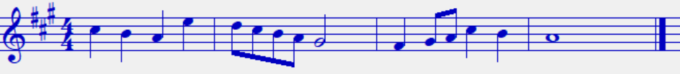
V7

========================

SECTION B : HISTORY AND ANALYSIS (54 MARKS)
3.AFRICAN MUSIC (14 marks)
a)Name two Kenyan ground bows. (02 marks)
………………………………………………………………………………………………………………………………………………………………………………………………………………
b)How is Orutu played ? (03 marks)
………………………………………………………………………………………………………………………………………………………………………………………………………………………………………………………………………………………………………………………
c)Giving examples of dances , list two factors that influence the naming of traditional dances in Kenya. (02 marks)
………………………………………………………………………………………………………………………………………………………………………………………………………………………………………………………………………………………………………………………
d)In which three ways is African traditional music preserved ? (03 marks)
………………………………………………………………………………………………………………………………………………………………………………………………………………………………………………………………………………………………………………………
e)State two advantages of call and response as a style of African performance (02 marks)
………………………………………………………………………………………………………………………………………………………………………………………………………………………………………………………………………………………………………………………………………………………………………………………………………………………………

f) State two reasons why music is used in hunting. (02 marks)
………………………………………………………………………………………………………………………………………………………………………………………………………………………………………………………………………………………………………………………
4.WESTERN PRESCRIBED COMPOSERS
Answer any two of the Questions (a) , (b) , (c) and (d).
a) Giovanni da Palestrina
i) How did Palestrina’s style reflect the ideals of the counter – reformation? (03 marks)
………………………………………………………………………………………………………………………………………………………………………………………………………………………………………………………………………………………………………………………………………………………………………………………………………………………………
ii) What are the key characteristics of Palestrina’s polyphonic style? (04 marks)
………………………………………………………………………………………………………………………………………………………………………………………………………………………………………………………………………………………………………………………………………………………………………………………………………………………………………………………………………………………………………………………………………
b) Henry Purcell
i) What is Purcell’s most famous opera? (01 mark)
………………………………………………………………………………………………………

ii) Outline three roles of Purcell at the English royal court (03 marks)
………………………………………………………………………………………………………………………………………………………………………………………………………………………………………………………………………………………………………………………………………………………………………………………………………………………………
iii) What is one special music technique Purcell used in Dido’s lament? (01 mark)
………………………………………………………………………………………………………
iv) How did Purcell’s music mix different styles? 2 marks
………………………………………………………………………………………………………………………………………………………………………………………………………………
c) Pyotr Ilych Tchaikovsky
i) Which type of work is sleeping beauty by Tchaikovsky? 1 mark
………………………………………………………………………………………………………
ii) What inspired Tchaikovsky’s 1812 overture? 1mark
………………………………………………………………………………………………………
iii) Give four factors that contributed to depression in his life 4 marks
………………………………………………………………………………………………………………………………………………………………………………………………………………………………………………………………………………………………………………………………………………………………………………………………………………………………………………………………………………………………………………………………………………………………………………………………………………………………………………
iv) Name one example of incidental music by Tchaikovsky 1 mark
………………………………………………………………………………………………………

d) Igor Stravinsky
i)State two sources that influenced Stravinsky’s musical life and style. (02 marks)
………………………………………………………………………………………………………………………………………………………………………………………………………………………………………………………………………………………………………………………

ii)What is 12 – tone serialism? (01 mark)
………………………………………………………………………………………………………………………………………………………………………………………………………………
iii) Name three of his works where serialism has been used (03 marks)
………………………………………………………………………………………………………………………………………………………………………………………………………………………………………………………………………………………………………………………
iv) Apart from serialism, which other style did Stravinsky use ? 1 mark
………………………………………………………………………………………………………

5.PRESCRIBED TRADITIONAL AFRICAN MUSIC (10 marks)
Rendille Folksong – (PPMC recording)
a) Classify the instrument used in the recording. (01 mark)
………………………………………………………………………………………………………
b) Describe the opening section. (02 marks)
………………………………………………………………………………………………………………………………………………………………………………………………………………………………………………………………………………………………………………………
c)State three characteristics of African music evident in the recording. (03 marks)
………………………………………………………………………………………………………………………………………………………………………………………………………………………………………………………………………………………………………………………………………………………………………………………………………………………………

d) List two roles of voice in the recording. (02 marks)
………………………………………………………………………………………………………………………………………………………………………………………………………………

6. PRESCRIBED WESTERN MUSIC (10 marks)
Eine Klein Nachtmusik ( K 525) – ‘Allegro’ – W.A. Mozart
- To which key does the second theme modulate to in the exposition? (01 mark)
………………………………………………………………………………………………………
b) Give bar numbers that mark the codetta part (01 mark)
………………………………………………………………………………………………………
c) Give three techniques that Mozart used in bars 56-75 to create tension (03 marks)
………………………………………………………………………………………………………………………………………………………………………………………………………………………………………………………………………………………………………………………
d) Give three ways how the recapitulation differs from the exposition (03 marks)
………………………………………………………………………………………………………………………………………………………………………………………………………………………………………………………………………………………………………………………………………………………………………………………………………………………………………………………………………………………………………………………………………
e) What is a pedal? Give a bar number of the instrumental part where a tonic pedal has been used
2 marks
………………………………………………………………………………………………………………………………………………………………………………………………………………

7.UNPREPARED ANALYSIS (06 Marks)
Study the music below and answer the questions there after.
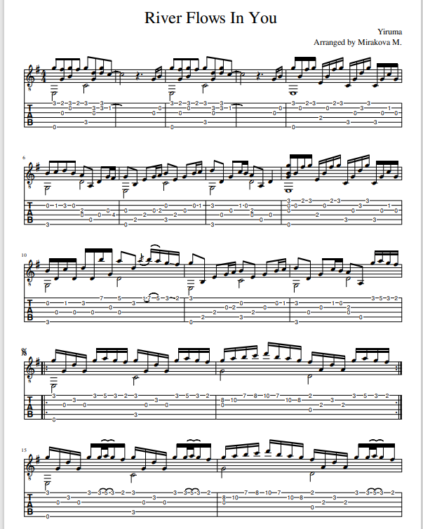
6a) What is the instrument for which the music is written? (01 mark)
………………………………………………………………………………………………………
b)For what purpose are the numbers on the staff for ? (01 mark)
………………………………………………………………………………………………………
c)Identify any two note extension methods used in this work. (02 marks)
………………………………………………………………………………………………………………………………………………………………………………………………………………
d)Name the ornament used in this work and write how it will be played. (02 marks)
i)Name………………………………………………………
ii)Playing
============
e)Identify any two music signs in this work , giving their meaning. (02 marks)
………………………………………………………………………………………………………………………………………………………………………………………………………………
f)i)What is the texture of this work. (01 mark)
………………………………………………………………………………………………………
ii)Give reason for your answer in (i) above. (01 mark)
……………………………………………………………………………………………………....

SECTION C : GENERAL MUSIC KNOWLEDGE (16 MARKS)
8 a) The following music is written for Saxophone in E flat. Write it for a trumpet in B flat
5 marks
============
b)Define the terms below. (05 marks)
i) Organal voice
………………………………………………………………………………………………………………………………………………………………………………………………………………
ii) Contralto
………………………………………………………………………………………………………………………………………………………………………………………………………………
iii) Kigamba
………………………………………………………………………………………………………………………………………………………………………………………………………………

iv) Music
………………………………………………………………………………………………………………………………………………………………………………………………………………
v) Composer
………………………………………………………………………………………………………………………………………………………………………………………………………………
c) Construct the G melodic minor scale , ascending and descending with the
key signature. (05 marks)

============
d)What is a cadenza? (01 mark)
………………………………………………………………………………………………………………………………………………………………………………………………………………

